**Q.1) WAP to print welcome message.**

**A.1) **

**Q.2) WAP to find sum of two numbers.**

**A.2)** 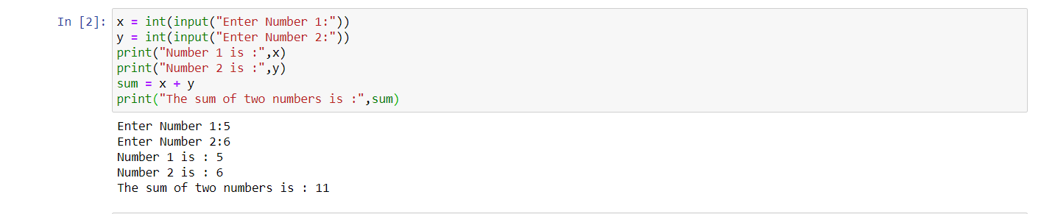

**Q.3) WAP to greet the user with first , middle and last name.**

**A.3)** 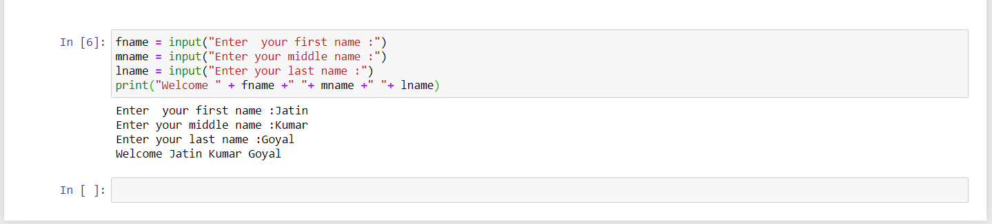

**LAB 2**

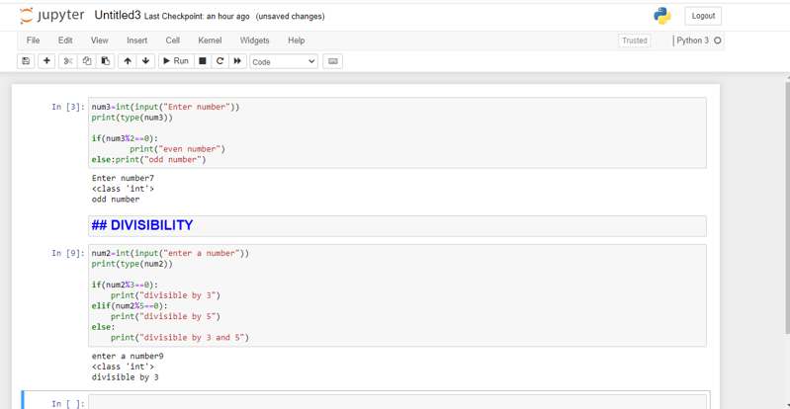

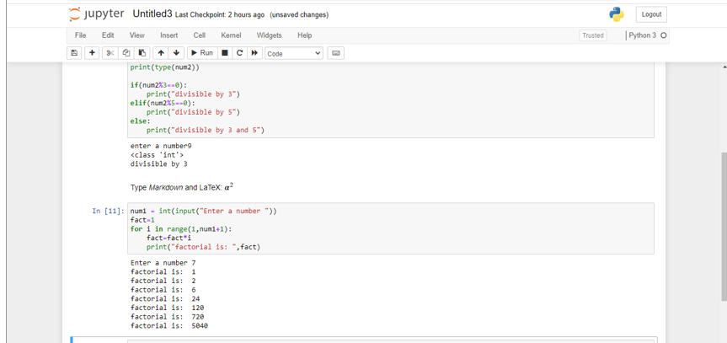

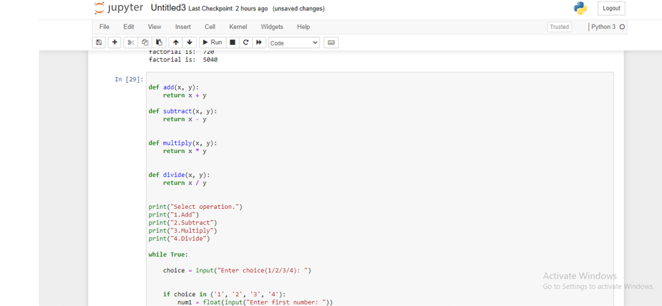

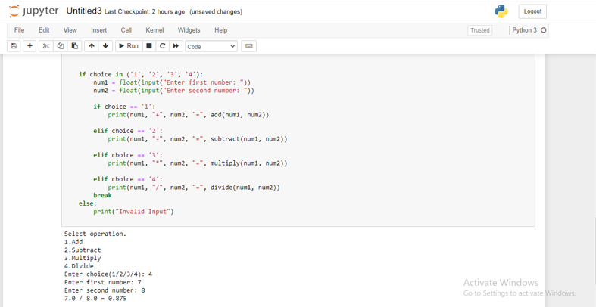

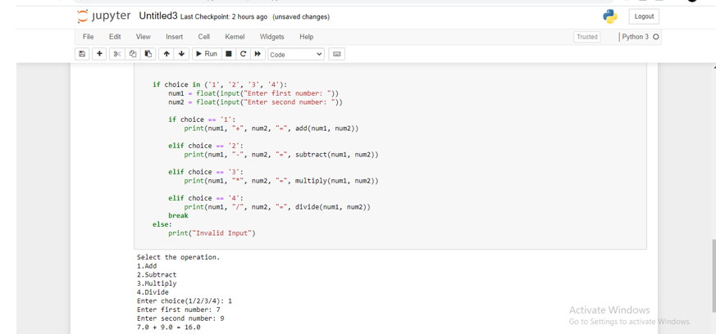

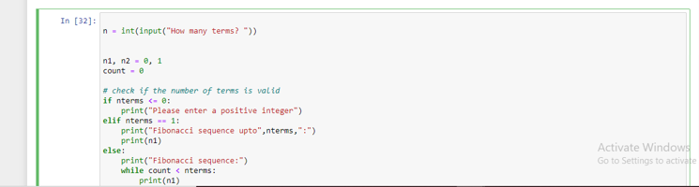

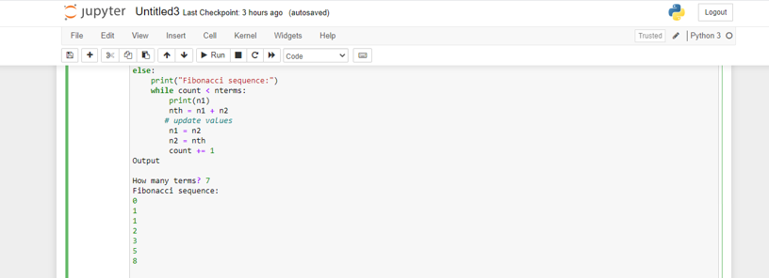

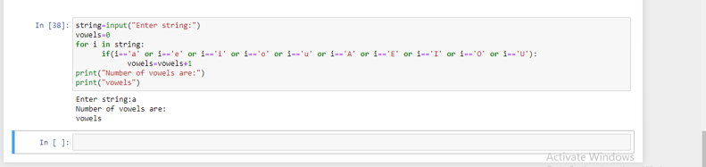

def pypartt(n):

for i in range(0, n+1):

for j in range(0, i+1):

print(" * ",end ="")

print("\r")

n = 5

pypartt(n)

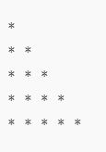

**LAB 3**

1. WAP to demonstrate while loop with else statement.

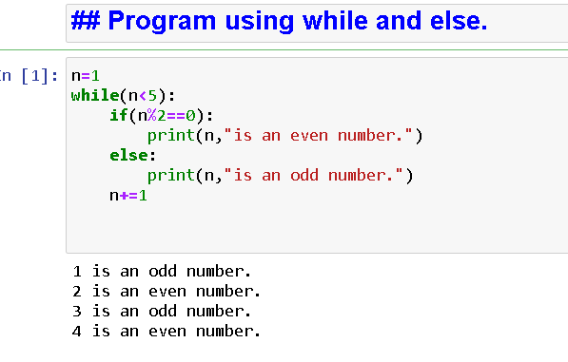

1. Print 1st 5 even numbers (use break statement).

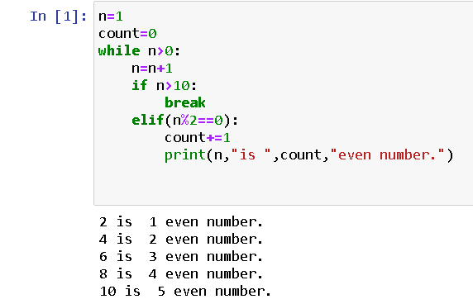

1. Print 1st 4 even numbers (use continue statement).

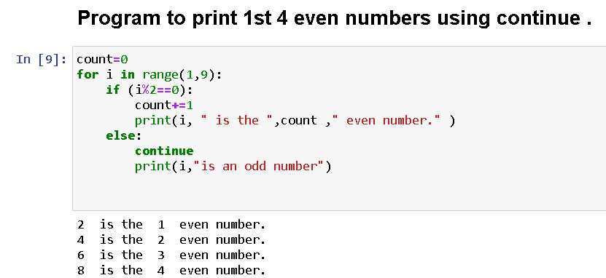

1. WAP to demonstrate Pass statements.

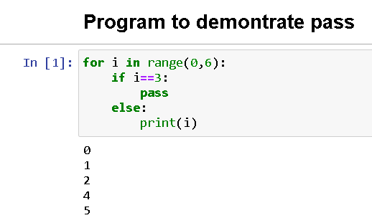

1. Write a Python program to calculate the length of a string.

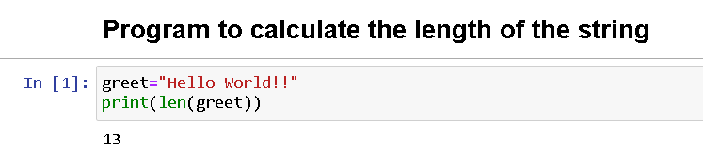

1. Write a Python program to count the number of characters (character frequency) in a string.

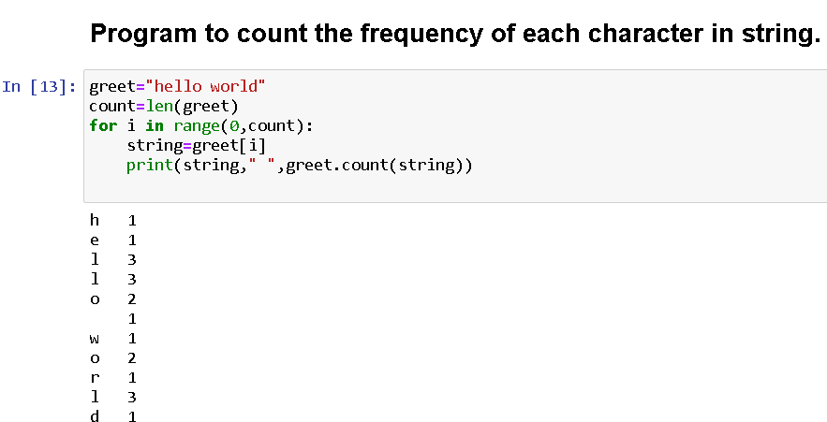

1. Write a Python program to get a string made of the first 2 and the last 2 chars from a given a string. If the string length is less than 2, return instead of the empty string.

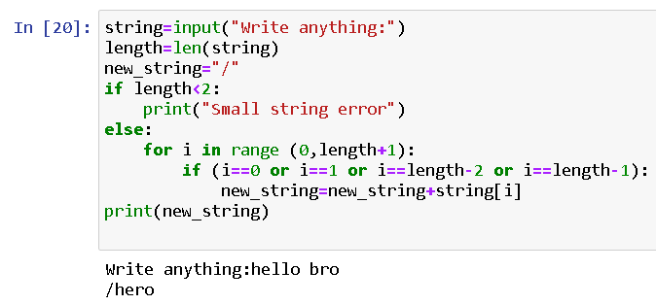

1. Write a Python program to get a string from a given string where all occurrences of its first char have been changed to '$', except the first char itself.

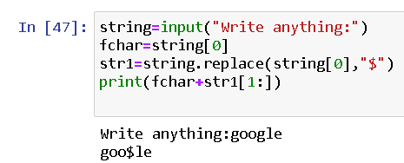

1. Write a Python program to get a single string from two given strings, separated by a space and swap the first two characters of each string.

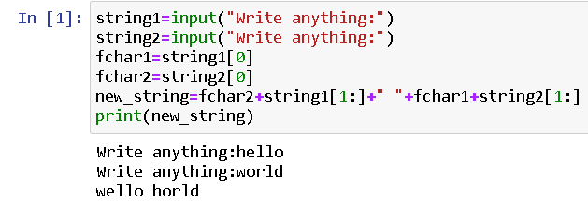

1. Write a Python program to add 'ing' at the end of a given string (length should be at least 3). If the given string already ends with 'ing' then add 'ly' instead. If the string length of the given string is less than 3, leave it unchanged.

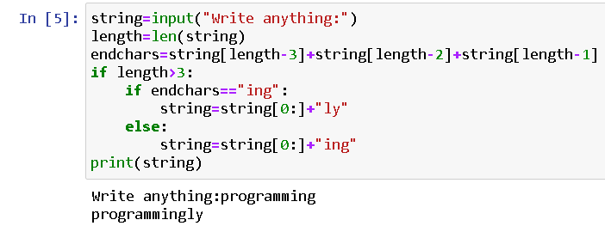

**LAB 4&5**

**Tuple**

**1.** Write a Python program to create a tuple.  t1= ()

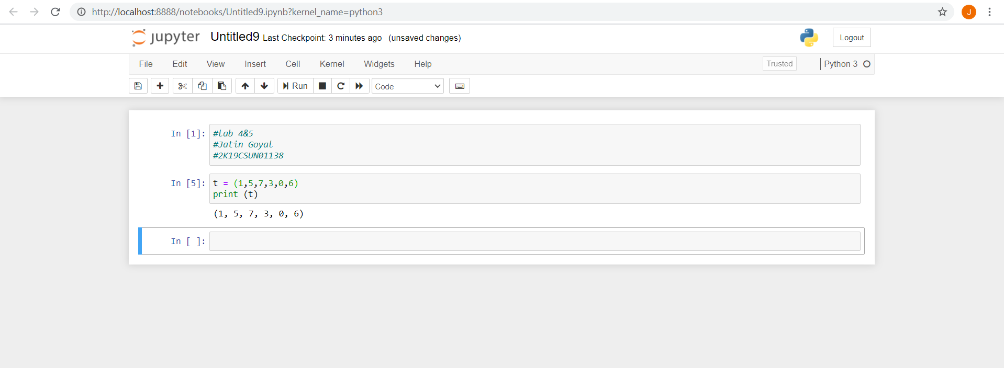

**2.** Write a Python program to create a tuple with different data types.

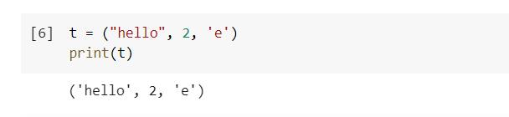

**3.** Write a Python program to create a tuple with numbers and print one item.

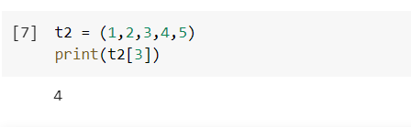

**4.**  Write a Python program to unpack a tuple in several variables.

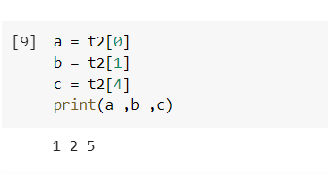

**5.** Write a Python program to add an item in a tuple.

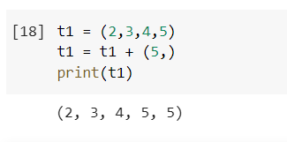

**6.** Write a Python program to convert a tuple to a string.

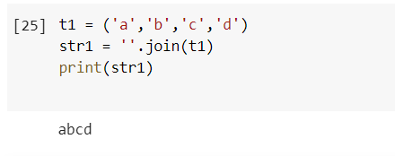

**7.** Write a Python program to get the 4th element and 4th element from last of a tuple

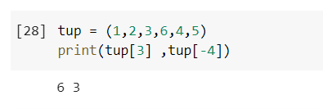

**8.** Write a Python program to create the colon of a tuple.

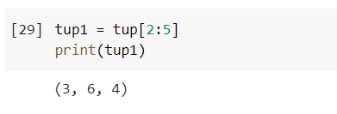

**9.** Write a Python program to find the repeated items of a tuple.

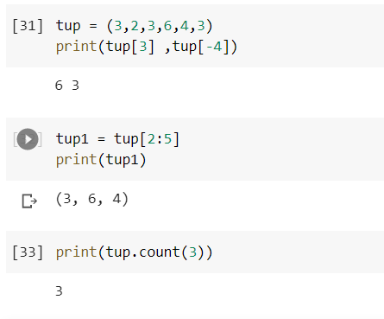

**10.** Write a Python program to check whether an element exists within a tuple.

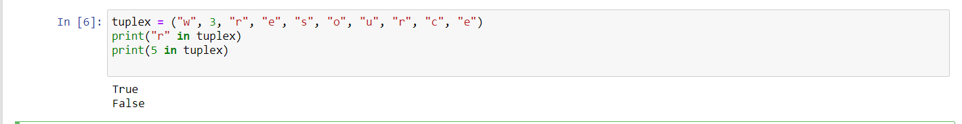

**11.** Write a Python program to convert a list to a tuple.

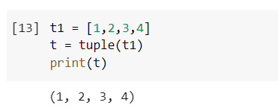

**12.** Write a Python program to remove an item from a tuple.

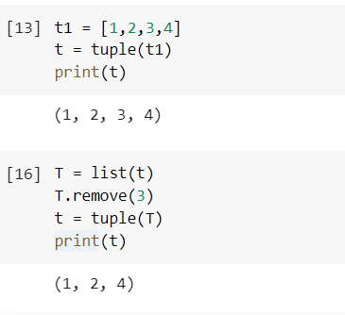

**13.** Write a Python program to slice a tuple

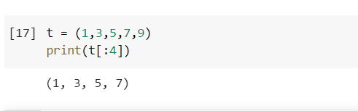

**14.** Write a Python program to find the index of an item of a tuple.

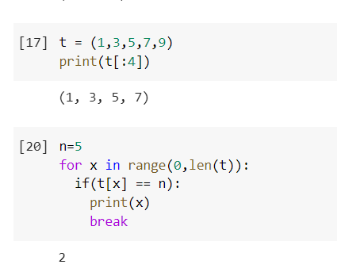

**15.** Write a Python program to find the length of a tuple.

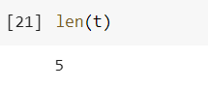

**16.** Write a Python program to reverse a tuple.

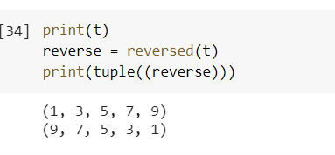

**List**

**1.** Write a Python program to sum all the items in a list.

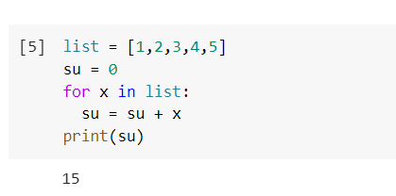

**2.** Write a Python program to multiplies all the items in a list. 

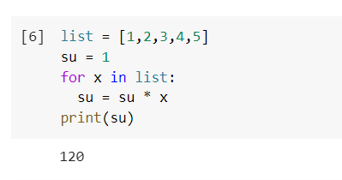

**3.** Write a Python program to get the largest number from a list

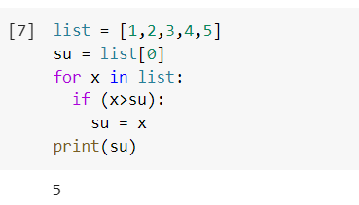

**4.**Write a Python program to get the smallest number from a list.

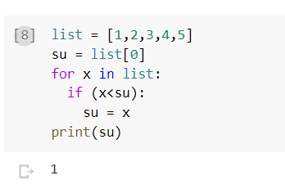

**5.** Write a Python program to count the number of strings where the string length is 2 or more and the first and last character are same from a given list of strings   
Sample List : ['abc', 'xyz', 'aba', '1221']  
Expected Result : 2

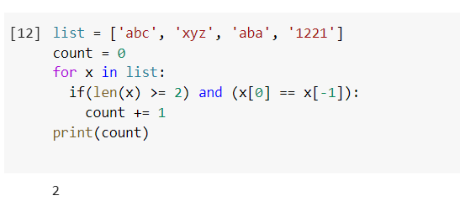

**7.**Write a Python program to remove duplicates from a list.

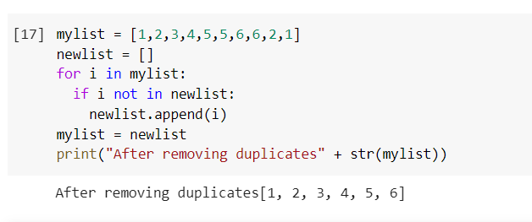

**8.**Write a Python program to check a list is empty or not.

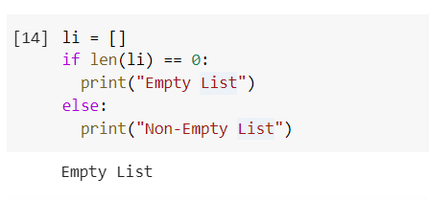

**9.**Write a Python program to clone or copy a list.

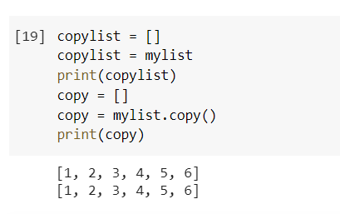

**11.**Write a Python function that takes two lists and returns True if they have at least one common member.

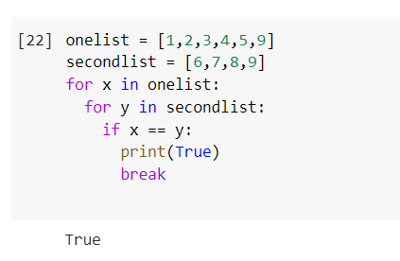

**12.**Write a Python program to print a specified list after removing the 0th, 4th and 5th elements.    
Sample List : ['Red', 'Green', 'White', 'Black', 'Pink', 'Yellow']  
Expected Output : ['Green', 'White', 'Black']  
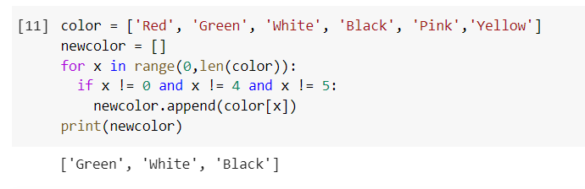

**LAB 6**

**DICTIONARY**

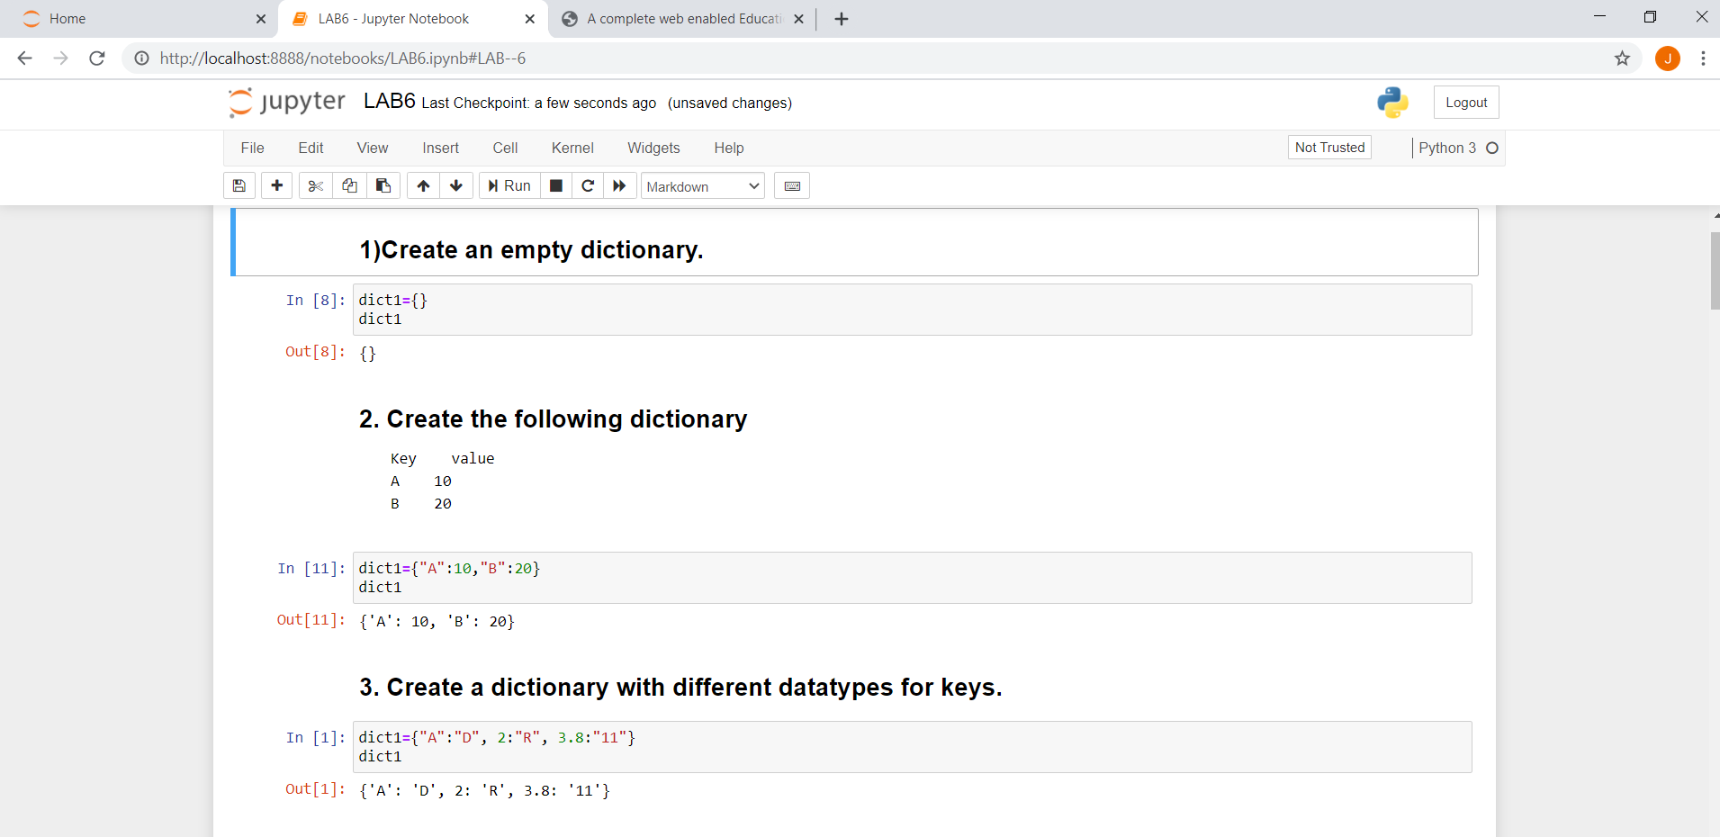

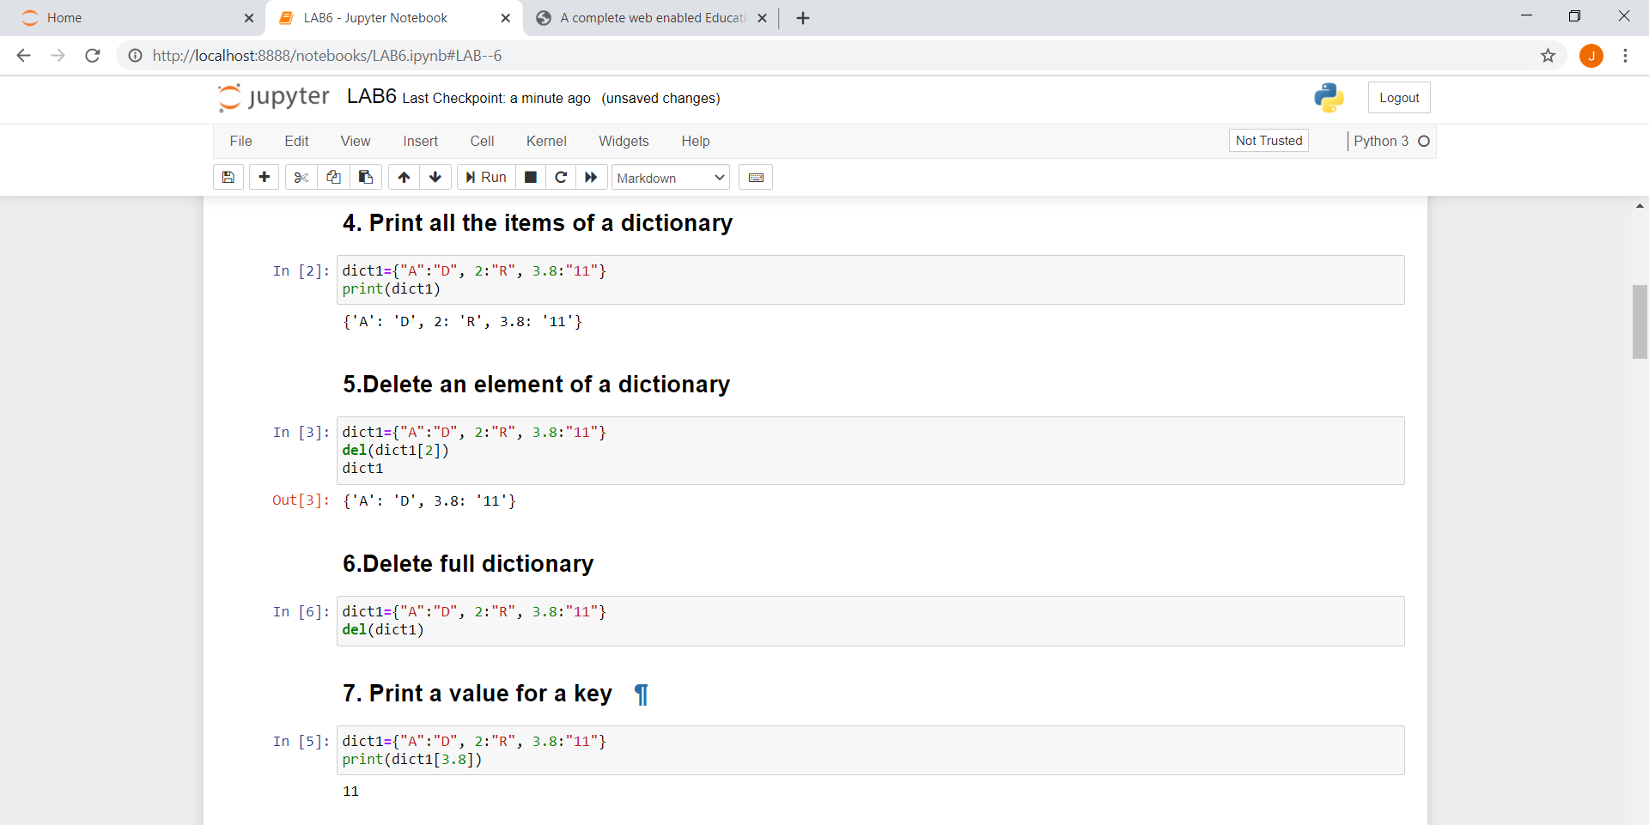

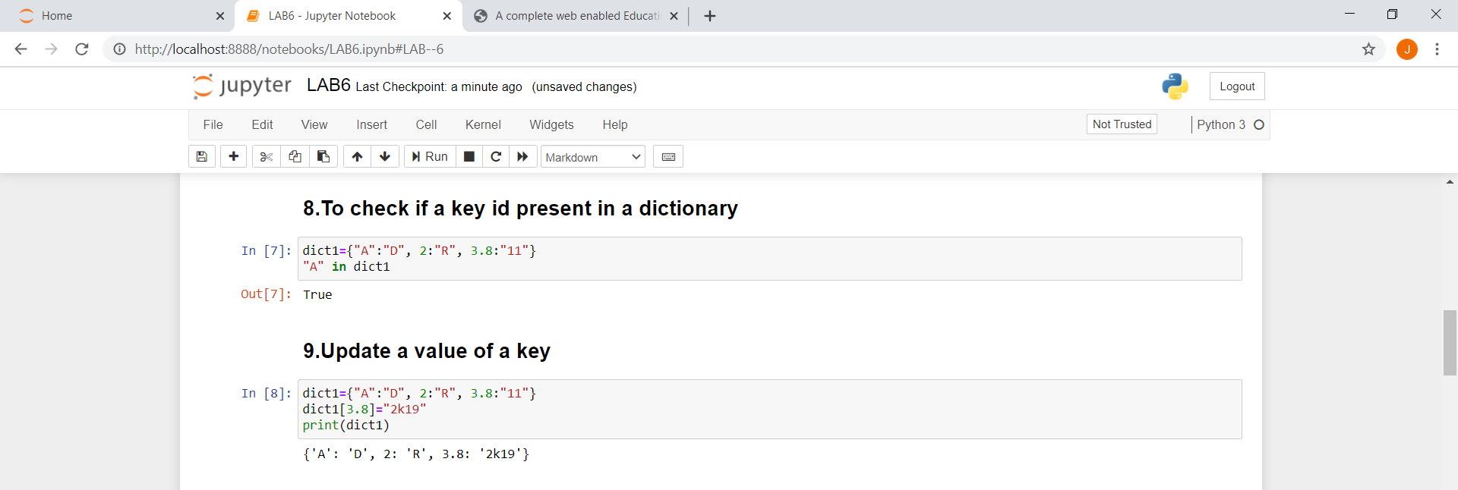

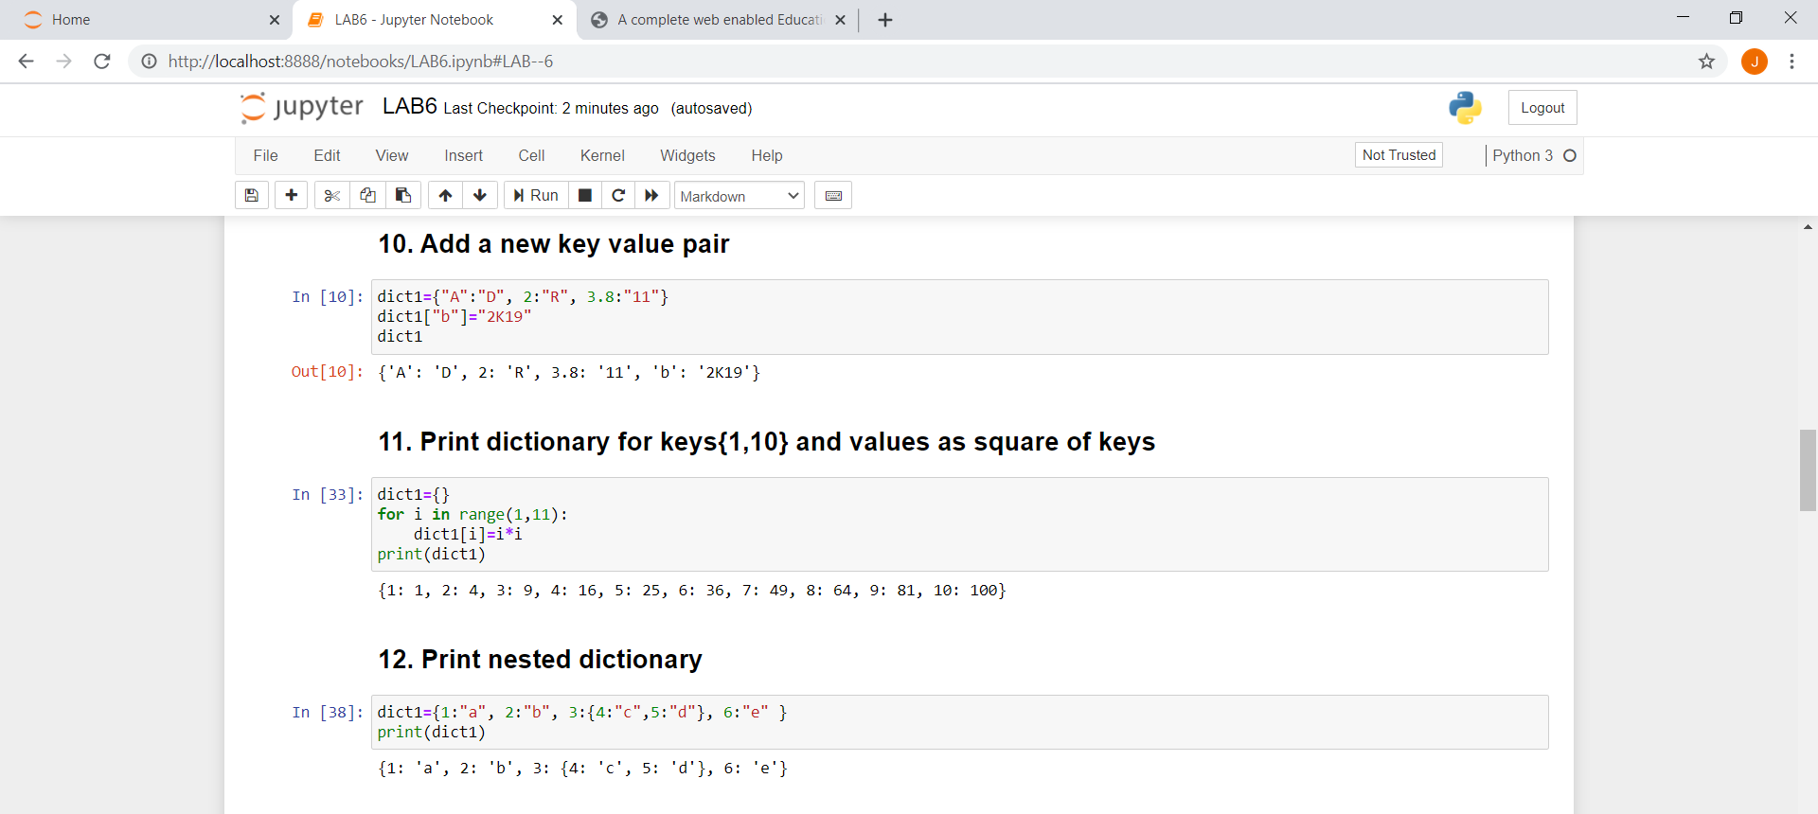

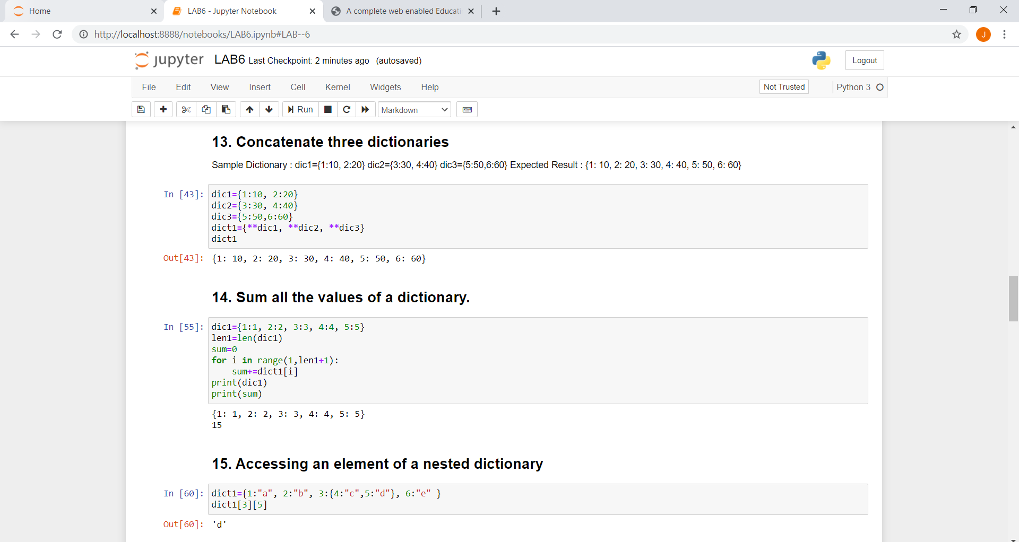

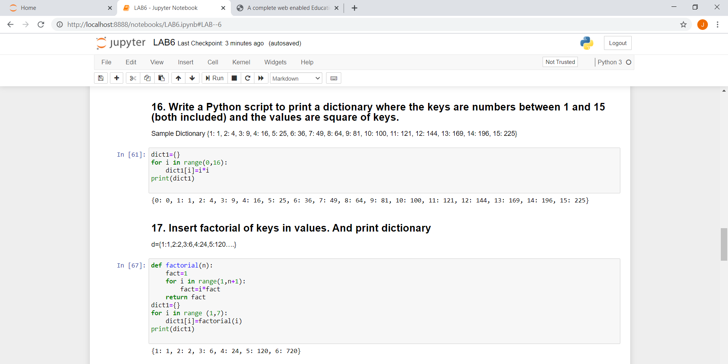

**SETS**

